Deal Desk Approval Process
Sales & Marketing Knowledge Hub | Sales Playbooks | Owner: Rachel Kim | Last updated: October 30, 2026

Section 1: Executive Summary & Scope
Describes the approval chain for non-standard terms, including custom contract language and extended payment terms. Section 1 (Executive Summary & Scope) applies to Sales Playbooks within Sales & Marketing Knowledge Hub and is maintained by Rachel Kim. Defines the operational charter, scope boundaries, and executive accountability.
Operational requirement 1.1: Non-standard payment terms over 60 days require finance approval. Secondary control 1.2: Custom legal terms are routed to legal with a 3 business day SLA.
- Non-standard payment terms over 60 days require finance approval.
- Custom legal terms are routed to legal with a 3 business day SLA.
- Section 1 review cadence is tracked by Rachel Kim under Sales Playbooks governance.
Control Area | Owner | Target SLA | Verification Status
Sales Playbooks | Rachel Kim | 5 business days | Verified
Deal Desk Approval Process Gate 1 | Rachel Kim | 3 business days | Active
Deal Desk Approval Process Gate 2 | Rachel Kim | 10 business days | Monitored
Page 1 of 7 | Sales & Marketing Knowledge Hub | Sales Playbooks | SharePoint Online

Section 2: Architecture & Process Flow
Describes the approval chain for non-standard terms, including custom contract language and extended payment terms. Section 2 (Architecture & Process Flow) applies to Sales Playbooks within Sales & Marketing Knowledge Hub and is maintained by Rachel Kim. Maps end-to-end process stages, handoff gates, and system-of-record integrations.
Operational requirement 2.1: Custom legal terms are routed to legal with a 3 business day SLA. Secondary control 2.2: Deals above a set contract value threshold require VP of Sales sign-off.
- Custom legal terms are routed to legal with a 3 business day SLA.
- Deals above a set contract value threshold require VP of Sales sign-off.
- Section 2 review cadence is tracked by Rachel Kim under Sales Playbooks governance.
Control Area | Owner | Target SLA | Verification Status
Sales Playbooks | Rachel Kim | 5 business days | Verified
Deal Desk Approval Process Gate 1 | Rachel Kim | 3 business days | Active
Deal Desk Approval Process Gate 2 | Rachel Kim | 10 business days | Monitored
Sec-2 | Rachel Kim | 3 business days | Stage 2 Verified
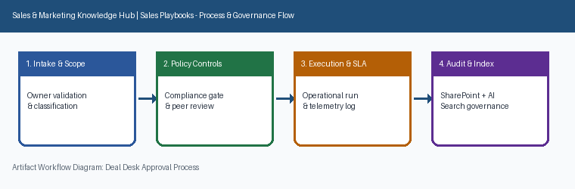
Page 2 of 7 | Sales & Marketing Knowledge Hub | Sales Playbooks | SharePoint Online

Section 3: Governance Standards & Controls
Describes the approval chain for non-standard terms, including custom contract language and extended payment terms. Section 3 (Governance Standards & Controls) applies to Sales Playbooks within Sales & Marketing Knowledge Hub and is maintained by Rachel Kim. Establishes mandatory compliance controls, approval thresholds, and audit evidence.
Operational requirement 3.1: Deals above a set contract value threshold require VP of Sales sign-off. Secondary control 3.2: Approved exceptions are logged to inform future template updates.
- Deals above a set contract value threshold require VP of Sales sign-off.
- Approved exceptions are logged to inform future template updates.
- Section 3 review cadence is tracked by Rachel Kim under Sales Playbooks governance.
Control Area | Owner | Target SLA | Verification Status
Sales Playbooks | Rachel Kim | 5 business days | Verified
Deal Desk Approval Process Gate 1 | Rachel Kim | 3 business days | Active
Deal Desk Approval Process Gate 2 | Rachel Kim | 10 business days | Monitored
Sec-3 | Rachel Kim | 10 business days | Stage 3 Verified
Page 3 of 7 | Sales & Marketing Knowledge Hub | Sales Playbooks | SharePoint Online

Section 4: Operational KPIs & Benchmarks
Describes the approval chain for non-standard terms, including custom contract language and extended payment terms. Section 4 (Operational KPIs & Benchmarks) applies to Sales Playbooks within Sales & Marketing Knowledge Hub and is maintained by Rachel Kim. Tracks baseline performance, target SLAs, and quarterly benchmark progression.
Operational requirement 4.1: Approved exceptions are logged to inform future template updates. Secondary control 4.2: Non-standard payment terms over 60 days require finance approval.
- Approved exceptions are logged to inform future template updates.
- Non-standard payment terms over 60 days require finance approval.
- Section 4 review cadence is tracked by Rachel Kim under Sales Playbooks governance.
Control Area | Owner | Target SLA | Verification Status
Sales Playbooks | Rachel Kim | 5 business days | Verified
Deal Desk Approval Process Gate 1 | Rachel Kim | 3 business days | Active
Deal Desk Approval Process Gate 2 | Rachel Kim | 10 business days | Monitored
Sec-4 | Rachel Kim | 5 business days | Stage 4 Verified
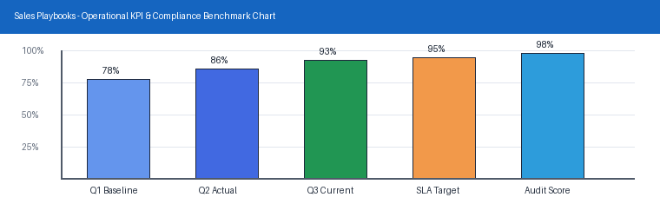
Page 4 of 7 | Sales & Marketing Knowledge Hub | Sales Playbooks | SharePoint Online

Section 5: Roles, Responsibilities & RACI
Describes the approval chain for non-standard terms, including custom contract language and extended payment terms. Section 5 (Roles, Responsibilities & RACI) applies to Sales Playbooks within Sales & Marketing Knowledge Hub and is maintained by Rachel Kim. Clarifies ownership across accountable executives, operational leads, and reviewers.
Operational requirement 5.1: Non-standard payment terms over 60 days require finance approval. Secondary control 5.2: Custom legal terms are routed to legal with a 3 business day SLA.
- Non-standard payment terms over 60 days require finance approval.
- Custom legal terms are routed to legal with a 3 business day SLA.
- Section 5 review cadence is tracked by Rachel Kim under Sales Playbooks governance.
Control Area | Owner | Target SLA | Verification Status
Sales Playbooks | Rachel Kim | 5 business days | Verified
Deal Desk Approval Process Gate 1 | Rachel Kim | 3 business days | Active
Deal Desk Approval Process Gate 2 | Rachel Kim | 10 business days | Monitored
Sec-5 | Rachel Kim | 3 business days | Stage 5 Verified
Page 5 of 7 | Sales & Marketing Knowledge Hub | Sales Playbooks | SharePoint Online

Section 6: Standard Operating Procedures
Describes the approval chain for non-standard terms, including custom contract language and extended payment terms. Section 6 (Standard Operating Procedures) applies to Sales Playbooks within Sales & Marketing Knowledge Hub and is maintained by Rachel Kim. Provides step-by-step execution checklists, intake criteria, and verification gates.
Operational requirement 6.1: Custom legal terms are routed to legal with a 3 business day SLA. Secondary control 6.2: Deals above a set contract value threshold require VP of Sales sign-off.
- Custom legal terms are routed to legal with a 3 business day SLA.
- Deals above a set contract value threshold require VP of Sales sign-off.
- Section 6 review cadence is tracked by Rachel Kim under Sales Playbooks governance.
Control Area | Owner | Target SLA | Verification Status
Sales Playbooks | Rachel Kim | 5 business days | Verified
Deal Desk Approval Process Gate 1 | Rachel Kim | 3 business days | Active
Deal Desk Approval Process Gate 2 | Rachel Kim | 10 business days | Monitored
Sec-6 | Rachel Kim | 10 business days | Stage 6 Verified
Page 6 of 7 | Sales & Marketing Knowledge Hub | Sales Playbooks | SharePoint Online

Section 7: Appendix, Lineage & Sign-off
Describes the approval chain for non-standard terms, including custom contract language and extended payment terms. Section 7 (Appendix, Lineage & Sign-off) applies to Sales Playbooks within Sales & Marketing Knowledge Hub and is maintained by Rachel Kim. Records document lineage, governance metadata, version history, and owner sign-off.
Operational requirement 7.1: Deals above a set contract value threshold require VP of Sales sign-off. Secondary control 7.2: Approved exceptions are logged to inform future template updates.
- Deals above a set contract value threshold require VP of Sales sign-off.
- Approved exceptions are logged to inform future template updates.
- Section 7 review cadence is tracked by Rachel Kim under Sales Playbooks governance.
Control Area | Owner | Target SLA | Verification Status
Sales Playbooks | Rachel Kim | 5 business days | Verified
Deal Desk Approval Process Gate 1 | Rachel Kim | 3 business days | Active
Deal Desk Approval Process Gate 2 | Rachel Kim | 10 business days | Monitored
Sec-7 | Rachel Kim | 5 business days | Stage 7 Verified
Page 7 of 7 | Sales & Marketing Knowledge Hub | Sales Playbooks | SharePoint Online

